Bastion host process

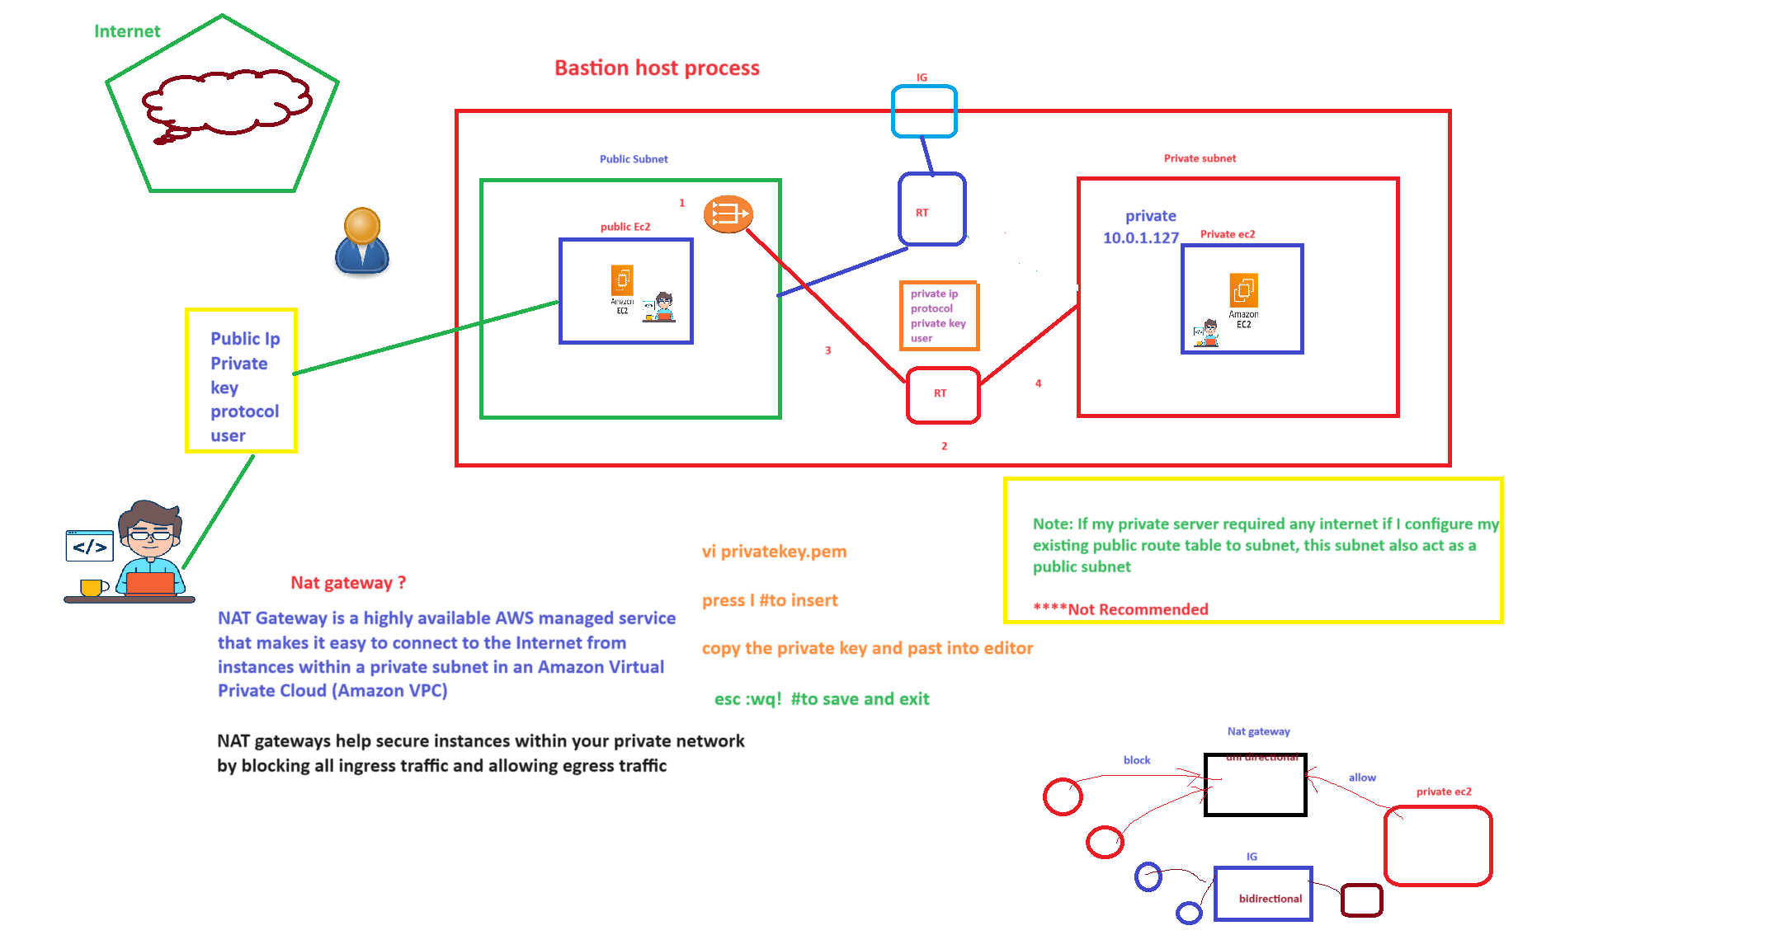

For bastion host process Nat gateway will not requires.

ls is to check the list of files

ls –al to check all files list

touch file is to create file

exit to go back to public server if we are in private server

rm –rf just delete file

rm –rf (file name) to delete the file

vi means editor

Connect public server to private server without Nat gateway

Case 1 by using only private IP

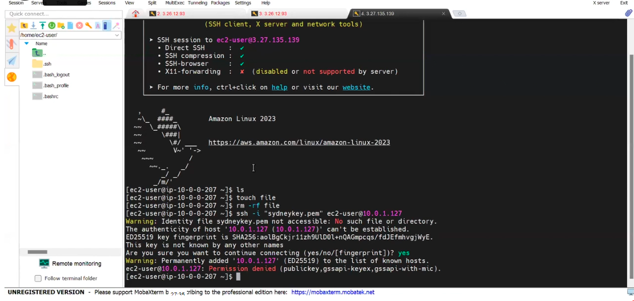

Error because private is not presented in public server 1.

So need to upload the private key to server, 2 way to upload key

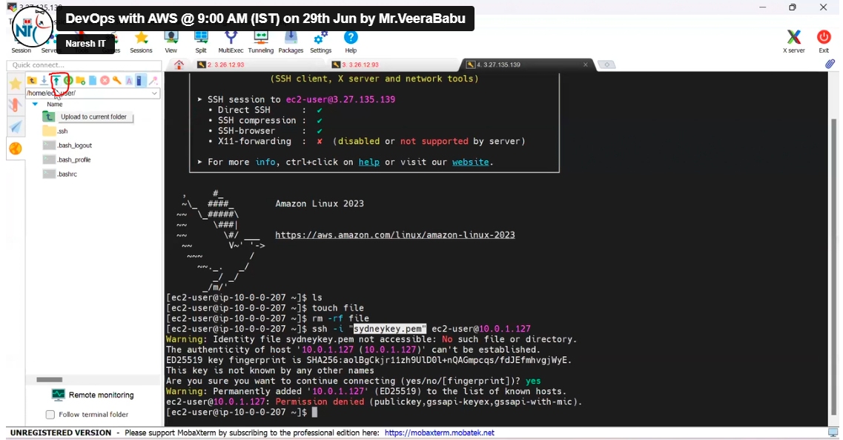

Click on upload and give the key

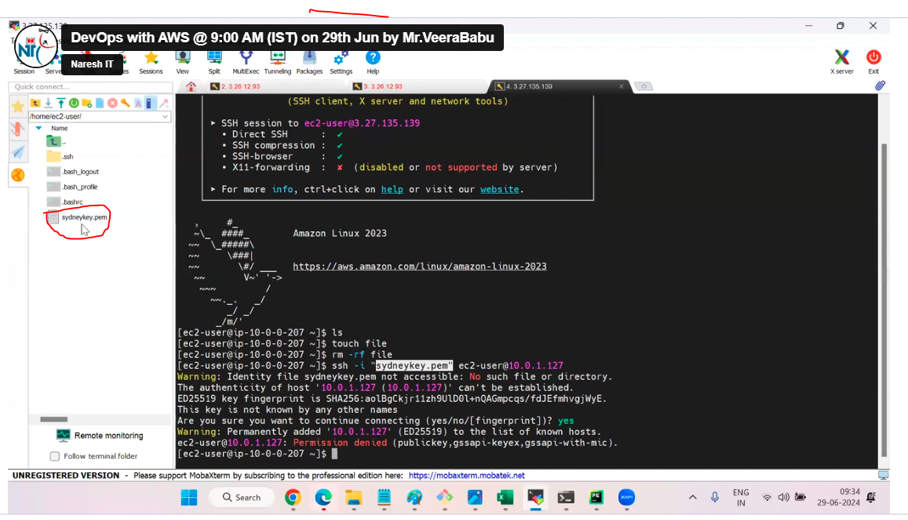

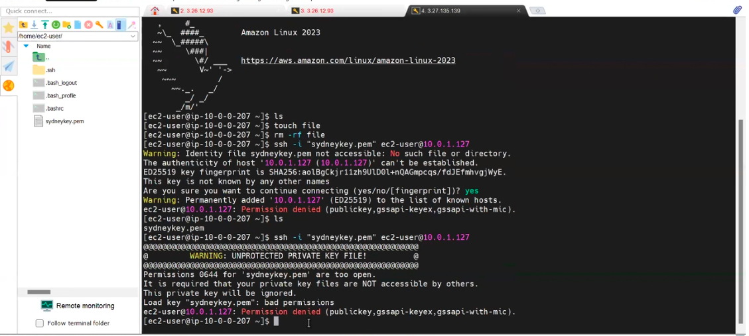

Again, error because we should use this command for read permission

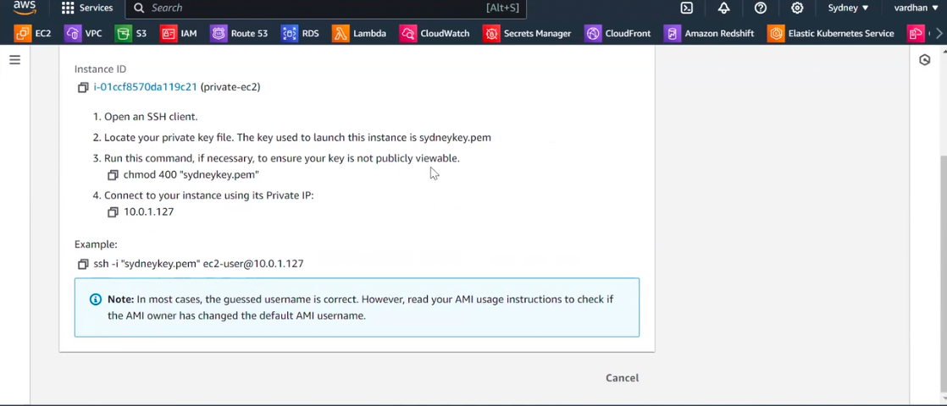

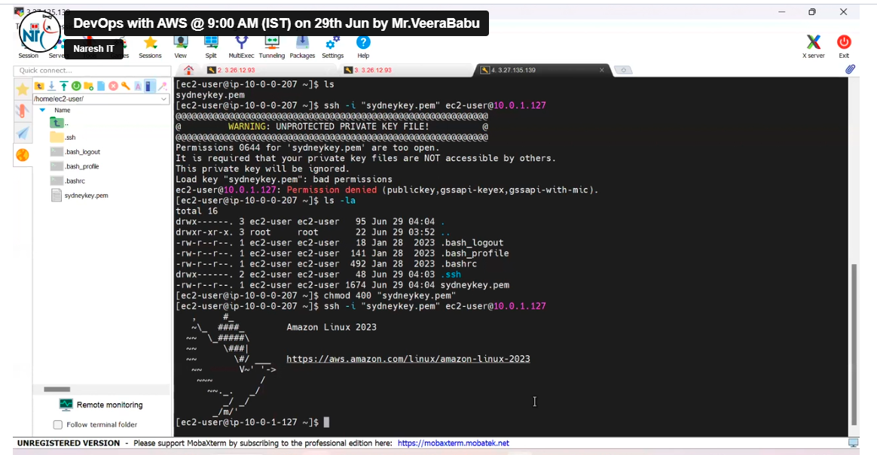

Now we are in private server.

For other method we have to remove the existing key for that ,we should have to move back to public server , exit command to go back to public server

Then use rm –rf file name to delete the private key

2 way by using vi

Here use vi (same name of key in folder). Example vi Sydney.pem

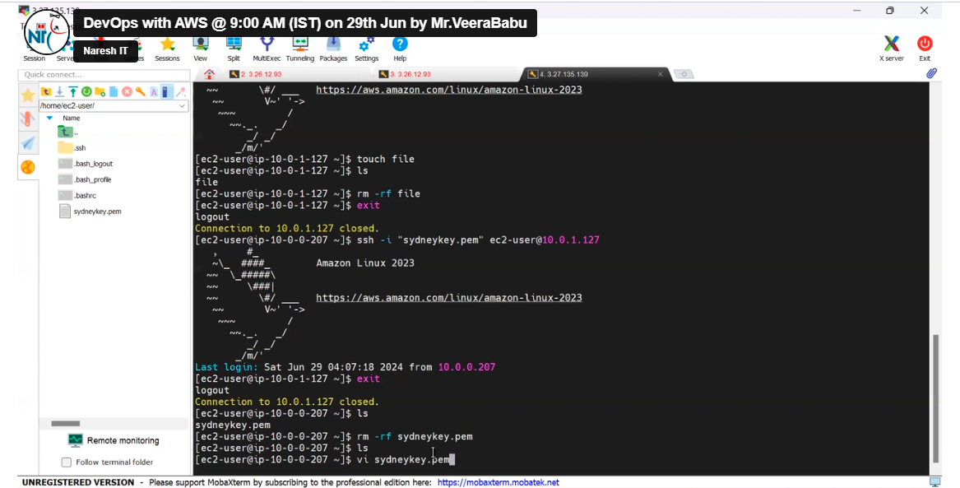

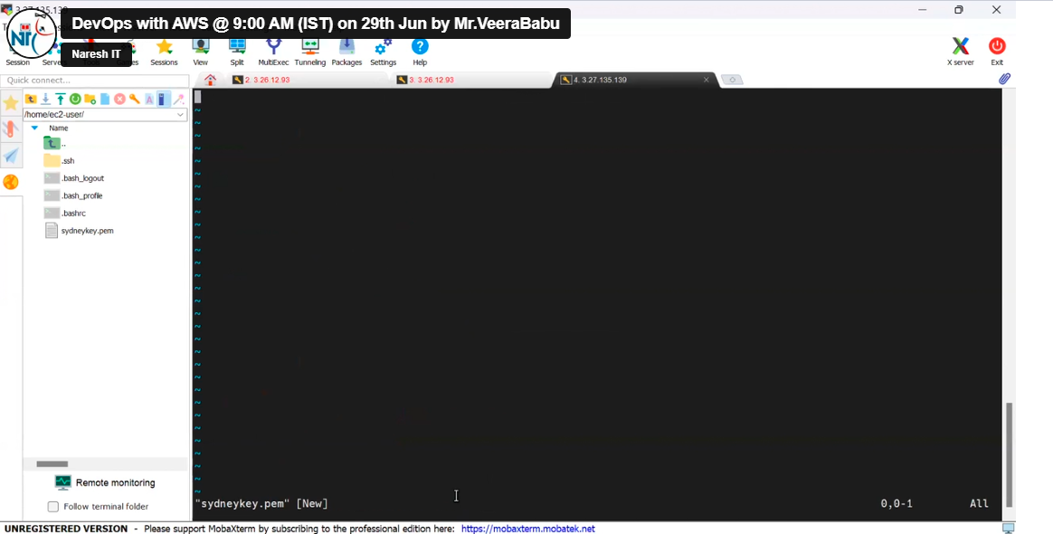

Copy the private key from local and just right click.

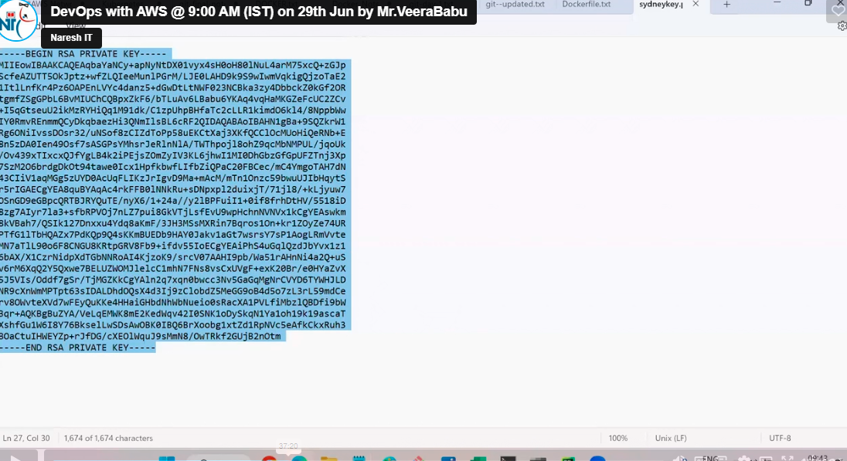

Press I to insert or edit ,here not required to copy paste.

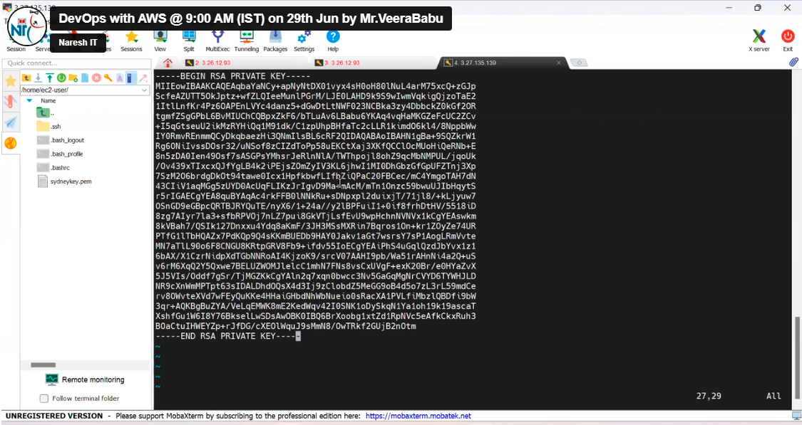

Then press

Esc

:wq!

#

To save the file and escape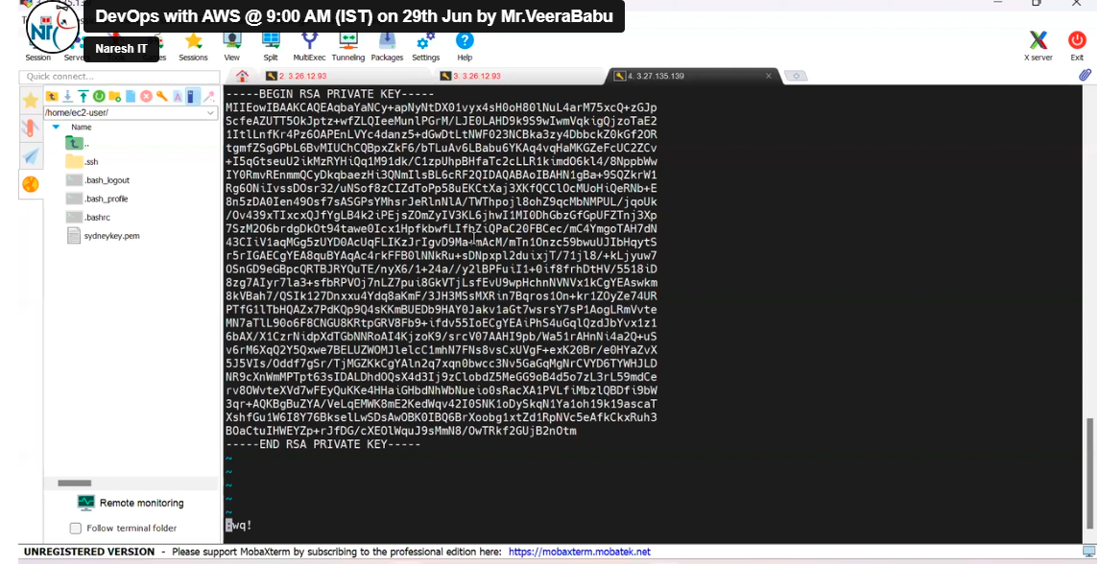

The give the red permission chmood 400 file name

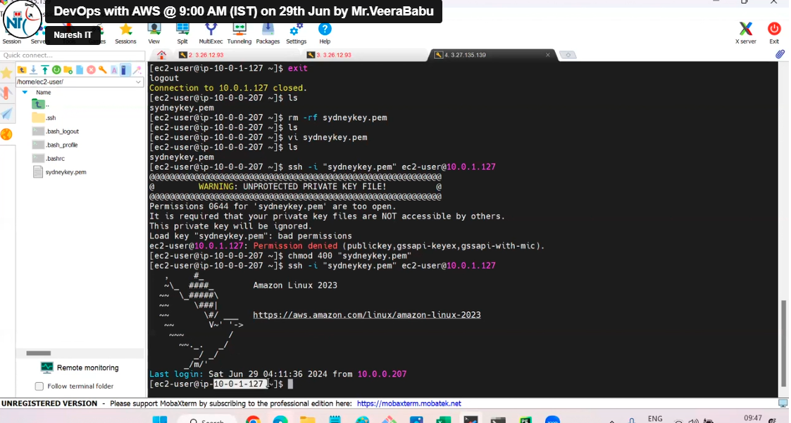

Now we are in public server.

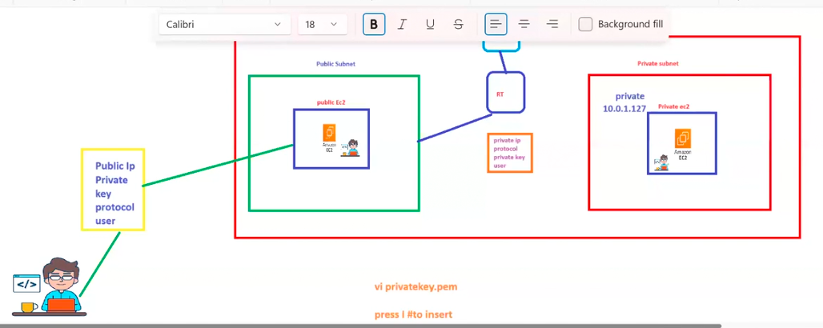

Now the bastion host process completed.

NAT GATEWAY

Nat gate way is unidirectional

Nat gate way helps secure instance with in your private network by blocking ingress (incoming) traffic and allowing egress-outgoing traffic

Nat gate way is subnet specific

IG is bi directional, which allows incoming and outgoing traffic.

IG is VPC specific.

To install packages in private server

We requires Nat gateway and route table

Sudo yum install git –y to install git

